**5D4N HANOI – HALONG – TAM COC/TRANGAN**

**DAY 1: HANOI – ARRIVAL ( D )**

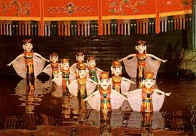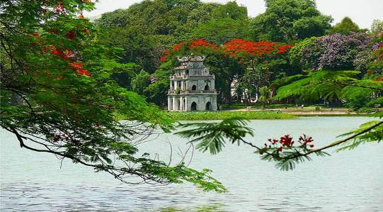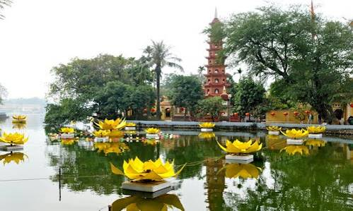

***Water Puppet Show HoanKiem Lake Tran Quoc Temple***

Upon arrival at NoiBai International airport, our representative will meet and transfer to Hanoi downtown to visit the **West Lake** with **Tran QuocPagoda**, **HoanKiemLake**(Restored Sword Lake) and shopping at **36 Old Quarter,** enjoy Vietnam famous **Water Puppet Show.**Dinner and overnight in Hanoi.

**Meals: 1 Dinner   
Accommodation: Overnight in Hanoi.**

***The distance: NoiBai Airport – Hanoi Capital: 35km – 45 minutes for transfer.***

**DAY 2: HANOI – HALONG (B/L/D)**

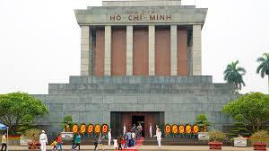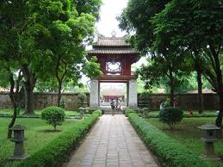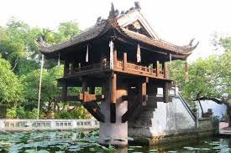

***Ho Chi Minh Mausoleum Temple Of Literature One Pillar Pagoda***

Breakfast at hotel, Transfer to visit **Ho Chi Minh Mausoleum,Ho Chi Minh Palace, Ba Dinh Square, Uncle Ho' Stilt House**, **One Pillar Pagoda**, continues to visit **Temple of Literature.**After lunch, transfer to Halong Bay - UNESCO World Heritage site (160km driving one way - 3.5hrs drive). This will be your first opportunity to see some of the rural areas of Vietnam. The drive goes through the Red River delta, so we'll have plenty of chance for taking photo of Vietnamese farmers tilling the vast green paddy field. Dinner and overnight in Halong.

**Meals: 1 Breakfast + 1 Lunch + 1 Dinner**

**Accommodation: Overnight in Halong**

***The distance: Hanoi – Halong Bay: 160km – 4 hours for transfer & break time on the way.***

**DAY 3: HALONG - HANOI (B/L/D)**

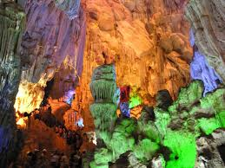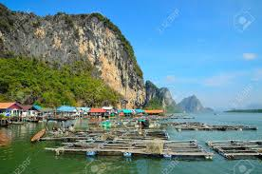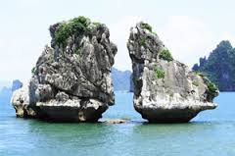

***Paradise Grotto Fisherman Village Kissing Chicken Rock***

After breakfast, transfer to Halong boat station to take our private boat to visit the world Heritage Halong Bay about 4 hours, our boat will bring us to visit **Paradise Grotto**, **Kissing Chicken Rock, Fisherman Village**, lunch will be served with fresh Halong Seafood, enjoy VietnamCoffeeon Cruise. Back to Hanoi, dinner and overnight in Hanoi.

**Meals: 1 Breakfast + 1 Lunch + 1 Dinner**

**Accommodation: Overnight in Hanoi**

***The distance: Halong - Hanoi: 160km – 4 hours for transfer & break time on the way.***

**DAY 4: HA NOI - TAM COC/TRANGAN – HANOI (B/L/D)**

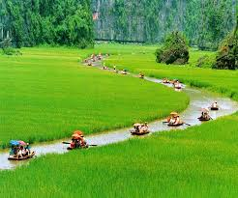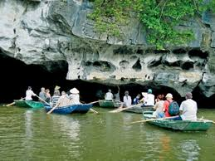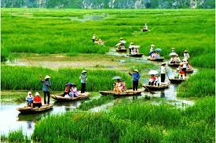

***Tamcoc River***

Options 1 :After breakfast, transfer to NinhBinh province, take sampan trip along the stream to visit **TamcocRiver**,Have a sightseeing the peaceful countryside of Vietnam. Discovering dry Halong bay Vietnam with rowing boat a long the streams and through many caves and visiting one of ancient citadel in Vietnam.Lunch at local restaurant, transfer back to Hanoi, dinner at local restaurant, overnight in Hanoi.

Options 2 :After breakfast, transfer to NinhBinh province, take sampan trip along the stream to visit to **Trang An** - The Tourism Complex in the northern province of NinhBinh was officially included in the world heritage list on June 23 by the UNESCO’s World Heritage Committee. The eco tourist attraction located in the East of NinhBinh, with area of 2000 ha, It includes 47 historical vestiges with many mysterious things, with limestone mountains, valleys and underground river systems. Take boat trip to visit cave complex: **Sang Cave, Toi Cave, Ba Giot Cave, NauRuou** in mystery and wildness, see scenery of mountain and rivers Ha Long on land of NinhBinh. The end of the day, drive back Hanoi.

**Meals: 1 Breakfast + 1 Lunch + 1 Dinner**

**Accommodation: Overnight in Hanoi**

***The distance: Hanoi – NinhBinh: 160km – 4 hours for transfer & break time on the way.***

**DAY 5: HANOI DEPARTURE (B)**

Breakfast at hotel, free at leisure then transfer to airport for flight home

**Meals: 1 Breakfast   
*The distance: Hanoi Capital - NoiBaiAirport : 35km – 45 minutes for transfer.***

**The ends of program!**

**SEQUENCE OF ITINERARY SUBJECT TO LOCAL ARRANGEMENT**

**PRICE INCLUDE:**

* Accommodation – as hotel in the list or similar – based on Twin/Double/Triple sharing
* Tour guide: **English or Chinese** speaking guide during the tour.
* Daily ABF and meals as mentioned in the program
* Shows and sightseeing in schedule.
* Transportation by private air-conditioner.

01 bottle ( 500 ml )of drinking water for each pax per day.

* Meals **(Vietnamese Food & Chinese Food)** as the tour code (B: Breakfast, L: Lunch, D: Dinner) 8-10 USD/meal/pax+ one buffet at **SenTay Ho Restaurant**
* Free coke/beer/coffee/water on Halong Cruise.
* Boat fees private one in Halong and TamCoc/Trangan as mentioned in the program

**PRICE EXCLUDE:**

* International / Domestic flight ticket & airport tax (if have)
* Personal expenses: Tel, Fax, Mini Bar, Laundry,etc.
* Personal travel insurance
* **Compulsory Tip for local guide and driver (USD/pax/day)**

|  |  |
| --- | --- |
| Group Size | Tips in USD |
| 2 – 4pax | 6 |
| 5-7pax | 5 |
| 8 - up | 3 |

* Surcharge with other languages guide.
* Additional Meal will be surcharge 10usd/pax/meal.
* Surcharge at hotel case by case
  + Chinese New Year (TBA)
  + Gala Dinner on X’Mas (24, 25 Dec ) & New Year 31 Dec

|  |  |  |  |  |  |  |  |  |  |  |  |  |
| --- | --- | --- | --- | --- | --- | --- | --- | --- | --- | --- | --- | --- |
| **Hotel listed or Similar** | | **All rates are next in USD/PAX**  **valid Jan - Dec, 2020** | | | | | | | | | | |
| **Tour by private car / bus with private guide** | | | | | | | | | | |
| **HANOI** | **HALONG** | **2** | **3-4** | **5-6** | **7-9** | **10-12** | **13-15** | **15+1** | **20+1** | **25 +1** | **30+1** | **Sgl up** |
| Larosa 3*  Pomihoa 3*  First Eden 3*  Thang Long Espana 3*  Adamas 3*  Authentic 3* | Seastar 3*  Golden Bay Ha Long 3*  Sen Hotel 3* | **428** | **366** | **310** | **288** | **281** | **263** | **258** | **256** | **243** | **238** | **86** |
| Thang Long Opera 4*  Chalcedony 4  Hotel Kuretakeso 4*  Lan Vien 4* | Galaxy Ha Long 4*  Au Lac 4*  Mithrin 4*  Song Loc 4* | **466** | **406** | **349** | **328** | **323** | **301** | **291** | **288** | **276** | **271** | **125** |

**NOTE**

The timing of sightseeing points shall be fixing by local operator due to traffic and weather conditions, however all points must cover unless amendment or cancellation make by clients themselves (Non-refundable for any cancellation that made by clients)

Tour and price are subject to change without notice or incase of deduct number of pax in quoted group.

Small deviations in the tour program are sometimes necessary, depending on weather, road conditions, flight schedules and room availability.

Supplement charge for room rate in peak dates depends on the hotel category used. Compulsory gala dinner on X’mas, New Year’s Eve & Lunar New Year’s Eve to be advised upon booking. Prices for group of 15 persons up in 5 stars hotels sometime requires to re-quote bases on the hotel policy

**01 FOC for tour leader based on twin sharing basis include breakfast (domestic air ticket is not applicable**

**BUS**

|  |  |
| --- | --- |
| Group Size | Kind of Transportation |
| 1-2 pax | 4 seater |
| 3 pax | 7 seater |
| 4-9pax | 16 seater |
| 10-18 pax | 30 seater |
| 19-21 pax | 35 seater |
| 22 – 42 pax | 45 seater |

**OPTIONIAL INFO:**

1/ Trishaw to visit 36 old quarters 10 USD/1 pax/ 1 trishaw

2/Vietnamese traditional massage in Halong bay: 1h30 minutes including tips: 20 USD/ pax.

* Commisstion 10% for tour leader

**SHOPPING INFO:**

1/ Hanoi local products

2/ Halong duty free jewelry center

* Commision 5% for Tour Leader

**Tour request without shopping and no options will be surcharge 10USD/pax**

**CHILD POLICY**

* Infant below 2 years old sharing same room with parents is free of charge.
* Child below 12 yrs old sharing same room with 1 ADL is charged for 90%.
* Child below 12 yrs old with extra bed and sharing same room with parents is charged for 65%.
* Child below 12 yrs old No extra bed & sharing same room with parents is charged for 55%